------------------------------------------------- MINI PROJECT 1 -------------------------------------------------------------

**Date:**06-07-2022

**Name of the Student:**Poojitha Talari  
**Name of the trainer:**Harshee Pitroda  
**Course:**Python and Basics of ML

Q) You need to create a quiz game in python. The quiz needs to contain 5 questions relating to the subject python. The Quiz game asks the player questions about python. Each correct answer will score a point. At the end of the game, the program will reveal the player’s final score.

You have all freedom to create the quiz game –

* You can have the quiz game as either MCQ based with one correct answer OR you can create a quiz game where the user inputs the answer for the question
* You can give the option of “re-attempt” for the quiz
* You are free to add any more feature

**PROGRAM**

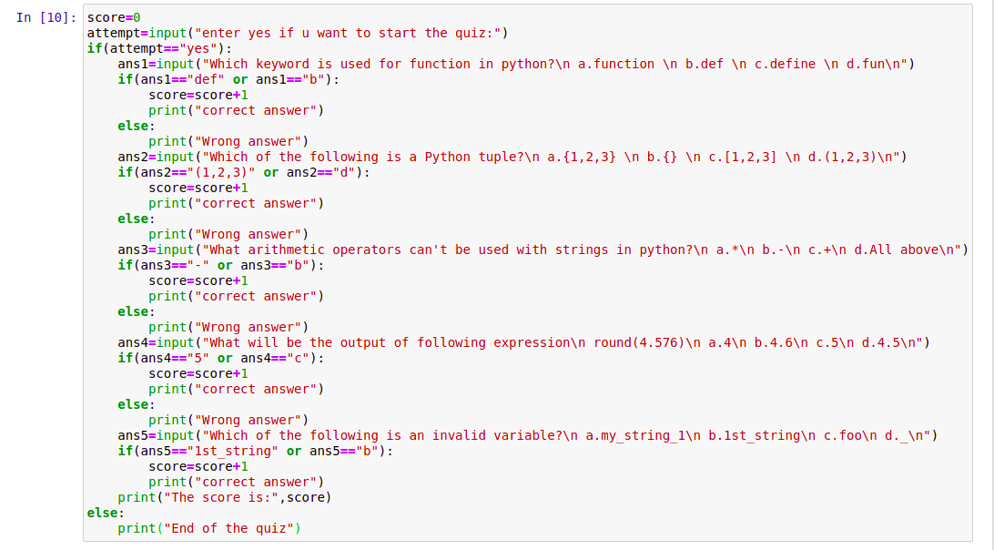

**OUTPUT:**

